RFID车灯标签
LA-10047

产品应用：
广泛应用于车辆电子环保信息卡、高速不停车电子收费、自助停车场、车辆自由行、车辆治堵引导、车辆超速等违章管理，车辆简单身份识别，车辆年检追朔管理、物流供应链数字化仓储、物品防伪及溯源监管，产品外形可根据客户需要定制。
Widely used in Vehicle electronic ticket in high way toll station, Certification card of environmental protection, automatic parking lot, Vehicle traffic lane control, Vehicle traffic guide, speeding violation management, simple vehicle identification, Vehicle annual inspection traceability management, logistics supply chain digital warehouse management and other high-end products traceability and security, tag size could be customized.
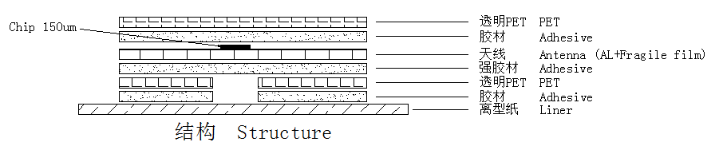

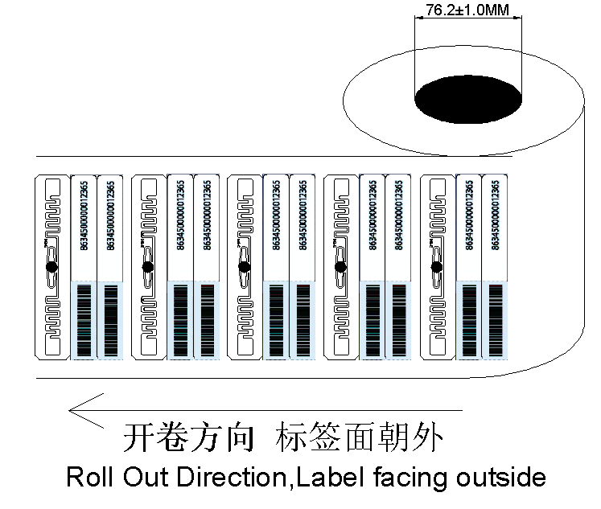

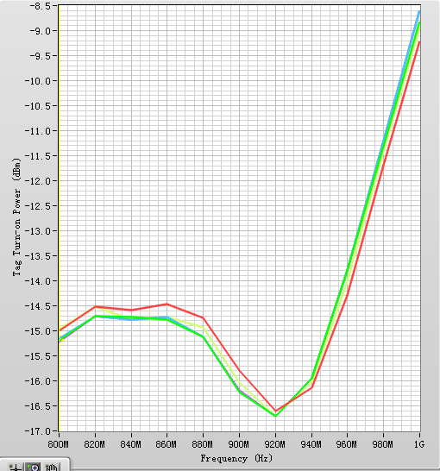
性能曲线参考图Reference of Graphic Performance

产品参数：

尺寸 Dimensions
天线尺寸Antenna Size 95X8mm(±0.2mm)
标签尺寸Tag Size 100X47mm(±0.5mm)
成品跳距Product Skip Distance 52.0±0.4mm
成品边距Product Margin 10.0±1.0mm
卷料宽度Width of the Tape 120±1.0mm
产品特性 Product Features

衬底基材Substrate Material 聚酯薄膜Polyester Film（PET ）
天线材料Antenna Material 铝蚀刻Aluminum Etching
表面材料Surface Material 防水Waterproof PET
外观特性Characteristics 透明、或者单双面彩色标签
Transparent, single or double side of color printing
工作频率Operating Frequency 860MHZ～960MHZ
工作协议Protocol ISO 18000-6C

标签芯片Chip IC Impinj Monza 4QT
TID：96bit
芯片内存容量 EPC_Public: 96bit
EPC_Private:128bit
Memory Capacity User：512bit
工作模式Operating Mode 清点或读写Inventory Read or Write
读写距离Read and write range ≥8M（Fixed Reader device）
重复编程次数Programming Cycle 100,000 cycles
个性化编码Personalized Coding 支持多种数据结构的内外组合编码方式（可 同步或离线式编码）；支持个性化密钥编码 Supporting multiple data structure of inside and outside combinatorial encoding（can be synchronous and offline sequence encoding）；Supporting
personalized key code
产品特性Product Attribute 一次性使用 ，局部防转移防篡改(如加温转移，化学转移，刀片转移等),抗UV紫外线设计，不残胶设计便于标签定期更换，抗水洗车外使用
Disposable，Prevent transfer copy(such as Heat
Transfer, Chemical transfer, Knife transfer, Anti-UV,
No residual of removal, Resistance of car water washing outside
性能一致性Performance Consistence 灵敏度一致Same RSSI or sensitivity
公差Tolerance +/-1dBm

环境参数Environmental Parameter

数据保存Data EEPROM Retention: 10 years
静电保护ESD Voltage Immunity: ± 2KV
工作温度Operating Temperature -25℃～75℃
储存温度Storage Temperature 0℃～25℃
操作湿度Relative Humidity: 10% ~ 95%(As Less Reading As More Humidity)
包装资料Packing Details

纸芯内径Core Diameter 76.2mm(3inch)
卷数量Volume Number 1000～3000PCS(依实际需求而定)
(According to actual demand)
出卷方向The Roll Direction 面标朝外（出卷方向依实际需求而定）
the Surface or Printing Facing out or up （According to actual demand）
包装材料Packing Material 防静电珍珠棉+气泡垫+防静电袋+外纸箱
Anti-static PE + Foam stuff + Anti-static Bag

